**1: EKS Storage Introduction**

--- In EKS storage we have different storages and provisioners.

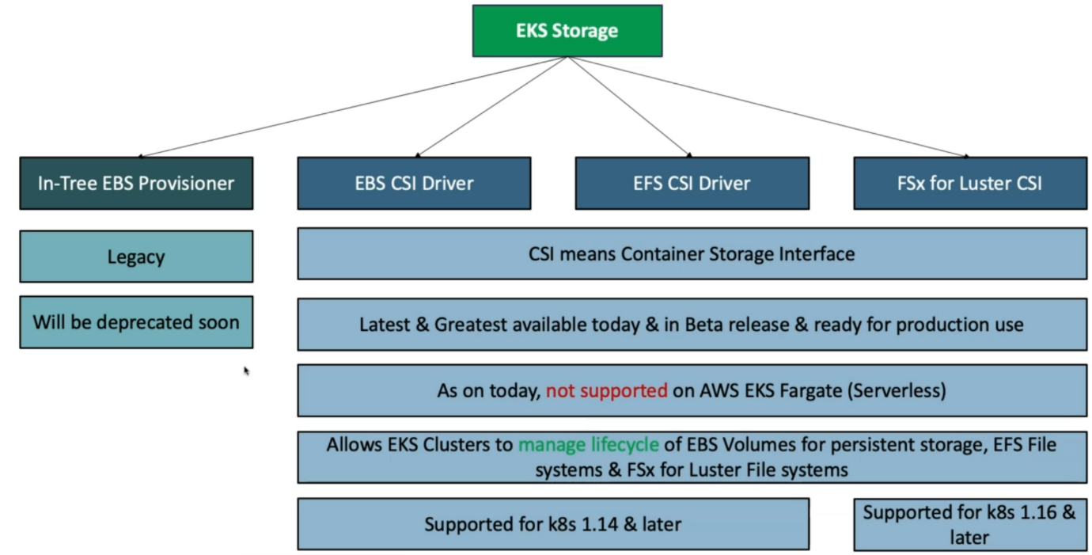

**EBS CSI Driver**

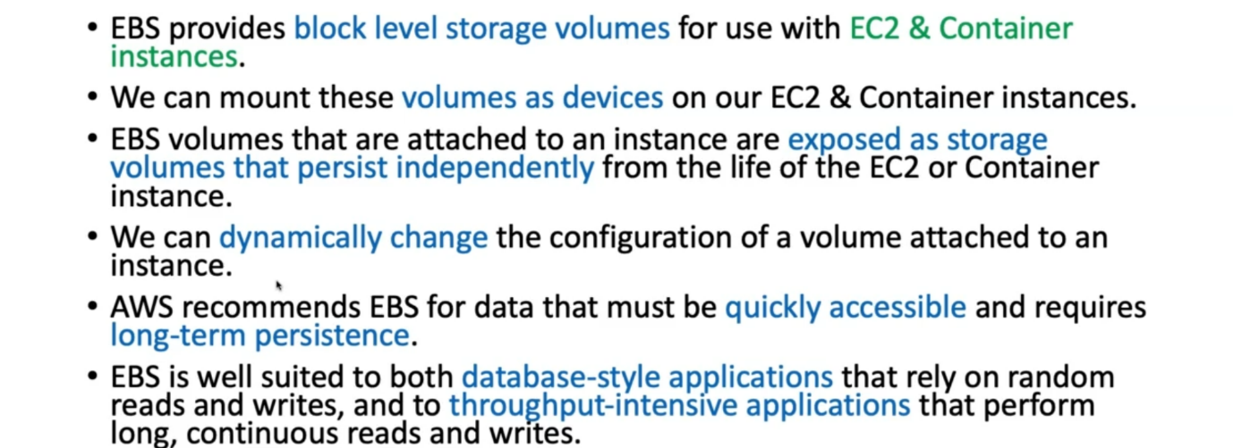

**What we are going to build on high level**

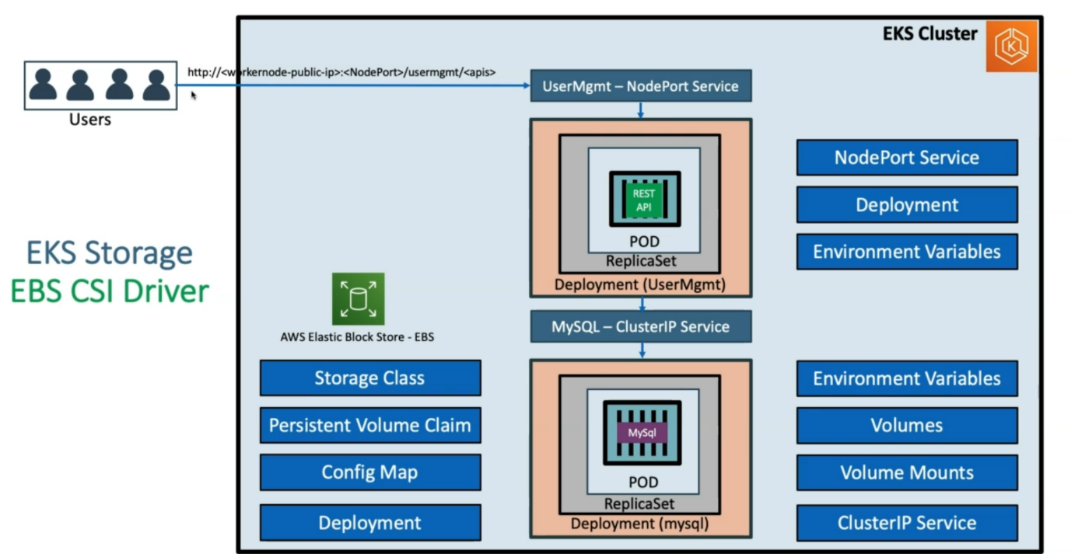

--- **note** - we are going to do a mysql deployment, for this mysql deployment we are going to leverage EBS volume mounts as the volume mounts inside the deployments. For this deployment we also going to learn about few other kubernetes concepts like storage class, persistent volume claim, config MAP, environmental variables, volumes, volume mounts.

--- here we are going to use dynamic volume provisioners.

--- the mysql deployment will use clusterip service, because will not going to expose mysql over internet.

--- **note** - now we are going to create a user management deployment, by this deployment I have created simple user management micro service where you will create a user, so, whenever a user is created then it will come and stored in mysql db. Here we will do a deployment with environmental variables to connect mysql db.

--- we are going to create a nodeport service for user management application, so you can access application over the internet.